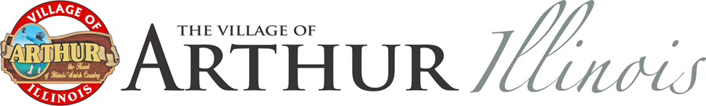

Memorial or Honorary Street Sign Program

The Memorial or Honorary Street Sign Program is designed to recognize past or living individuals who have contributed in some way to the well-being of this community or who otherwise deserve to be so remembered or honored.

A memorial or honorary sign can be installed and maintained when the following conditions are met:

- At least one immediate family member of the memorialized or honored individual must approve a request for a sign. An immediate family is a spouse, child, stepchild, brother, stepbrother, sister, stepsister, mother, stepmother, father, stepfather, or grandchild.

- The Village will not install or maintain a memorial or honorary sign if there is written opposition from any immediate family member.

- Memorial or honorary street signs will be installed in accordance with applicable Village policies and standards for street signs. This includes composition, hardware, color, etc. Signs will be installed in addition to existing street signs, not as replacements for existing street signs.

- The actual costs for the materials to create and install the sign will be paid for by the requestor.

- The Village will maintain the sign for a period of two years or unless the condition of the sign has deteriorated to a point where it is no longer serviceable, whichever comes first. The sign will be given to the requestor after it has been removed from service.

- The requested location of the memorial or honorary sign will be accommodated whenever possible. Multiple locations may be requested.
Actual costs for multiple signs will be paid by the requestor.

- Each memorial or honorary street sign will be approved by the Village of Arthur Board of Trustees.

Requestor: ____________________________________ Date: _______________

Requestor Address: __________________________________________________

Honoree: ______________________________________ Phone: _____________

Location(s): _________________________________________________________

Cost Estimate: $100-$125 Approved: _______ Not Approved: _______

